Student’s Name: Kibet Brian
Admission Number: 190814
Lecturer’s Name: Mr. Talo Harrison
Course Unit: MST 8303 Penetration Testing, PT
Course Code: MST 8303
Lab – Using Hydra to Brute Force a Password
Date: July 24th, 2025

Lab – Escalating Privileges
Attack Platform: Kali 10.9.51.31
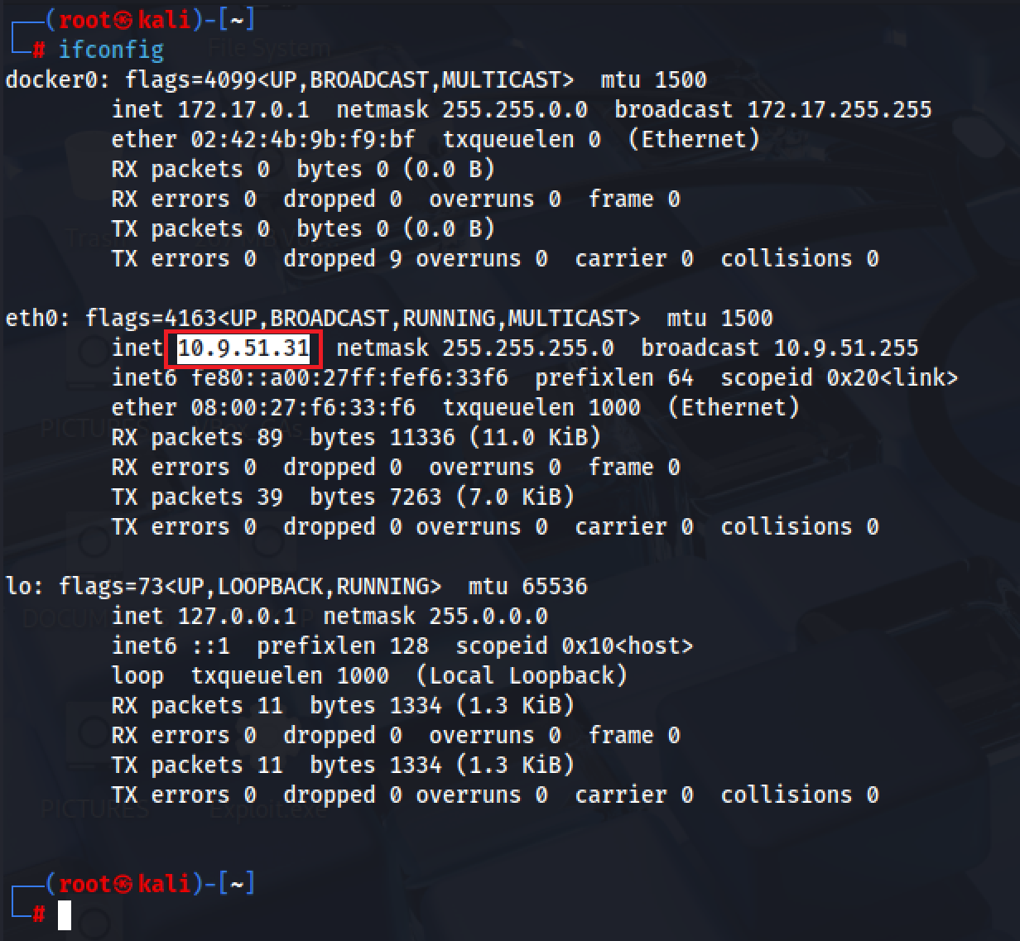

Target machine IP address: 10.9.51.4
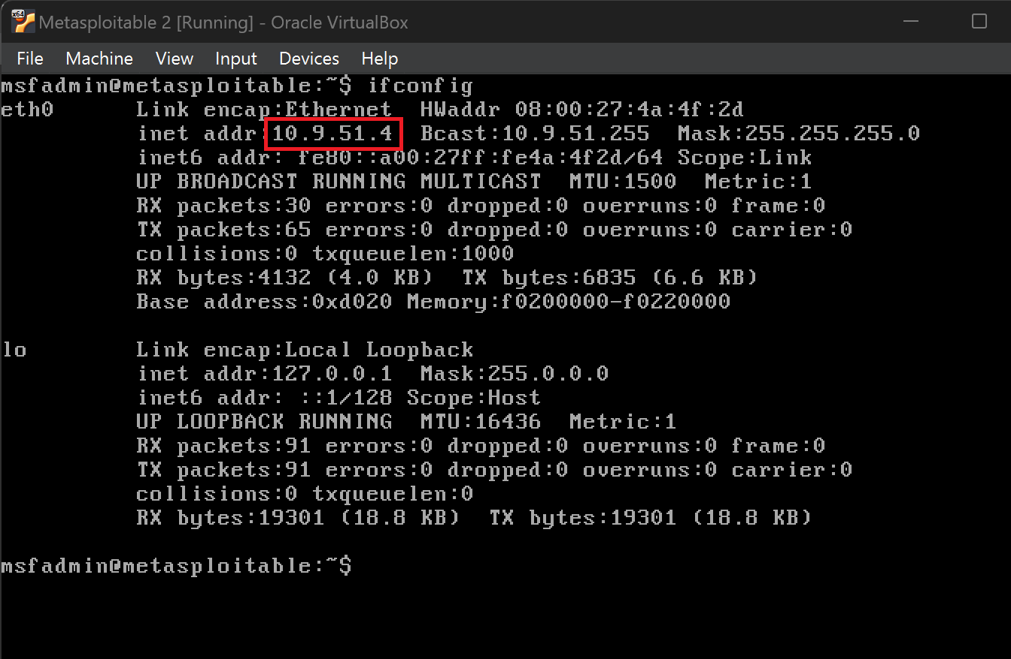

Both Machines are Nat Network configured.
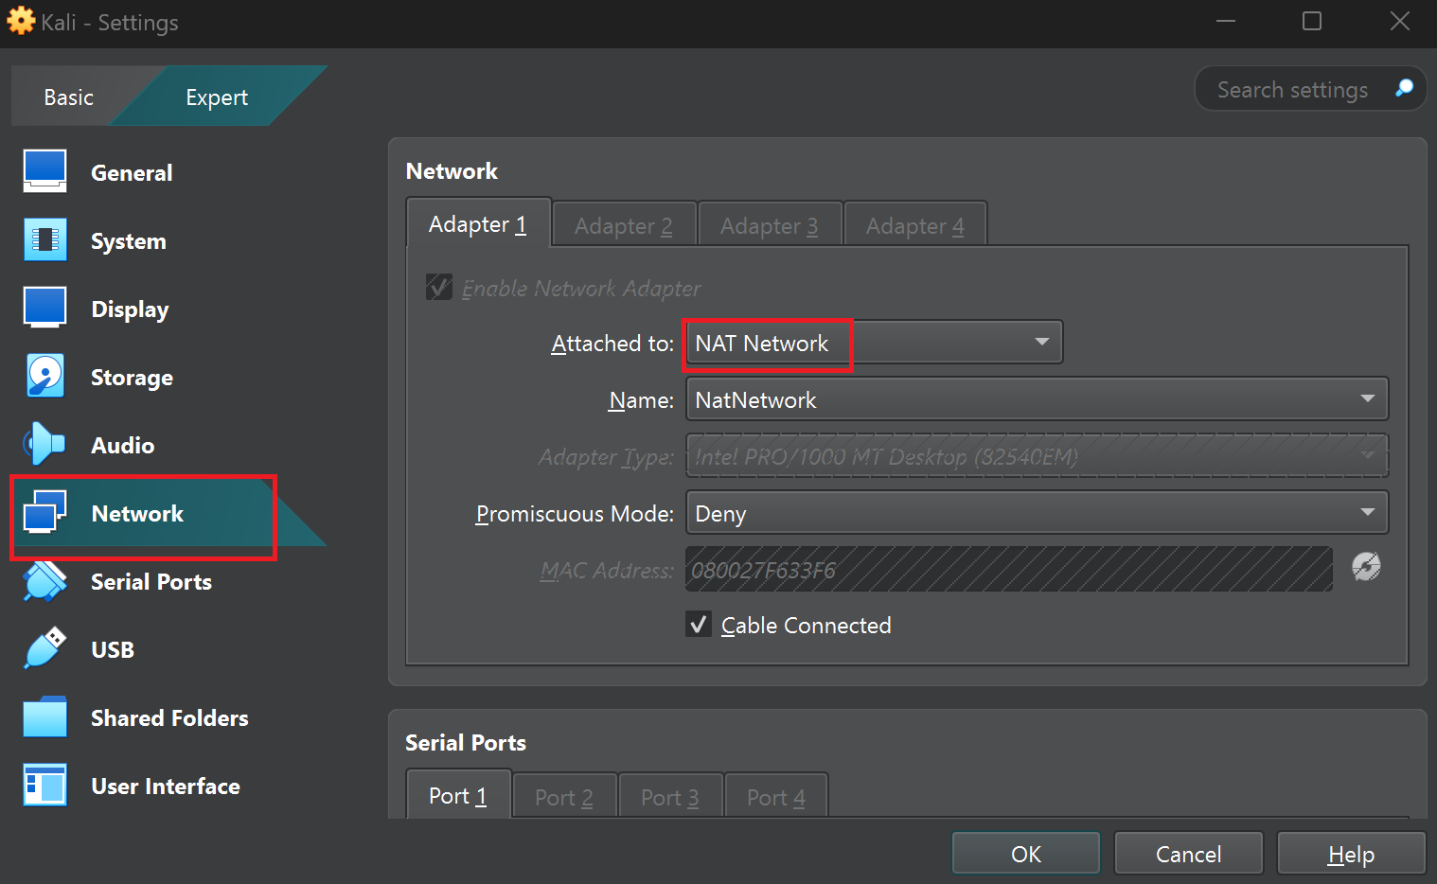

hydra-gtk was not found hence I chose to use XHydra
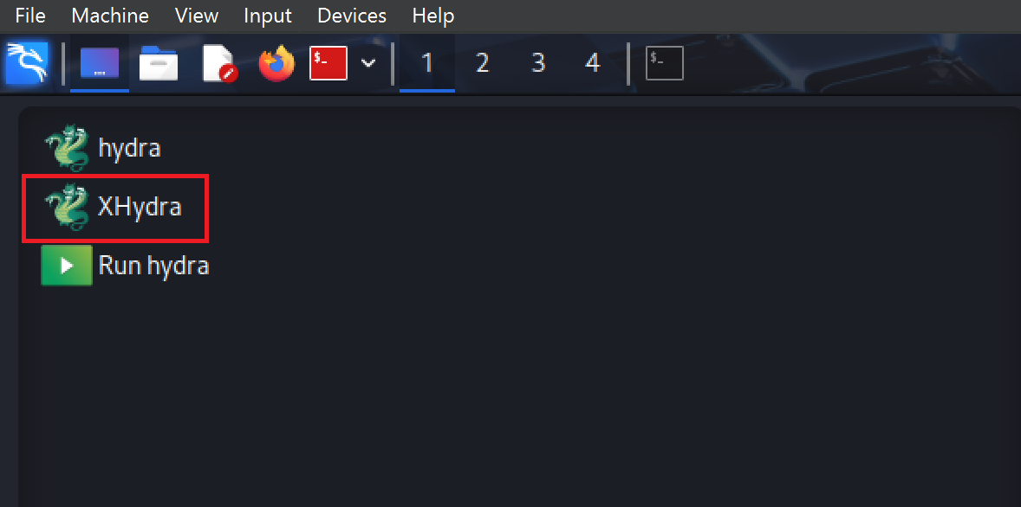

Set up in the target tab
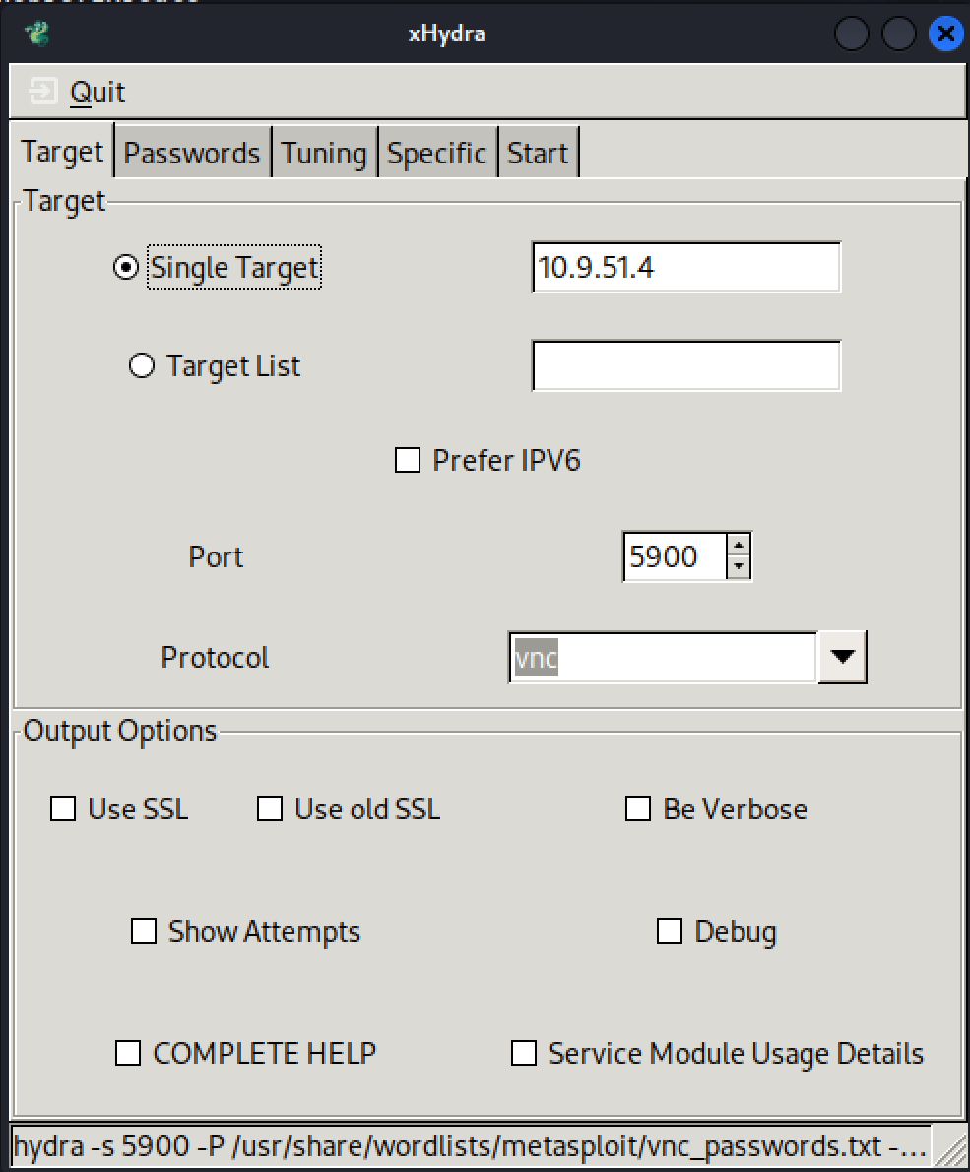

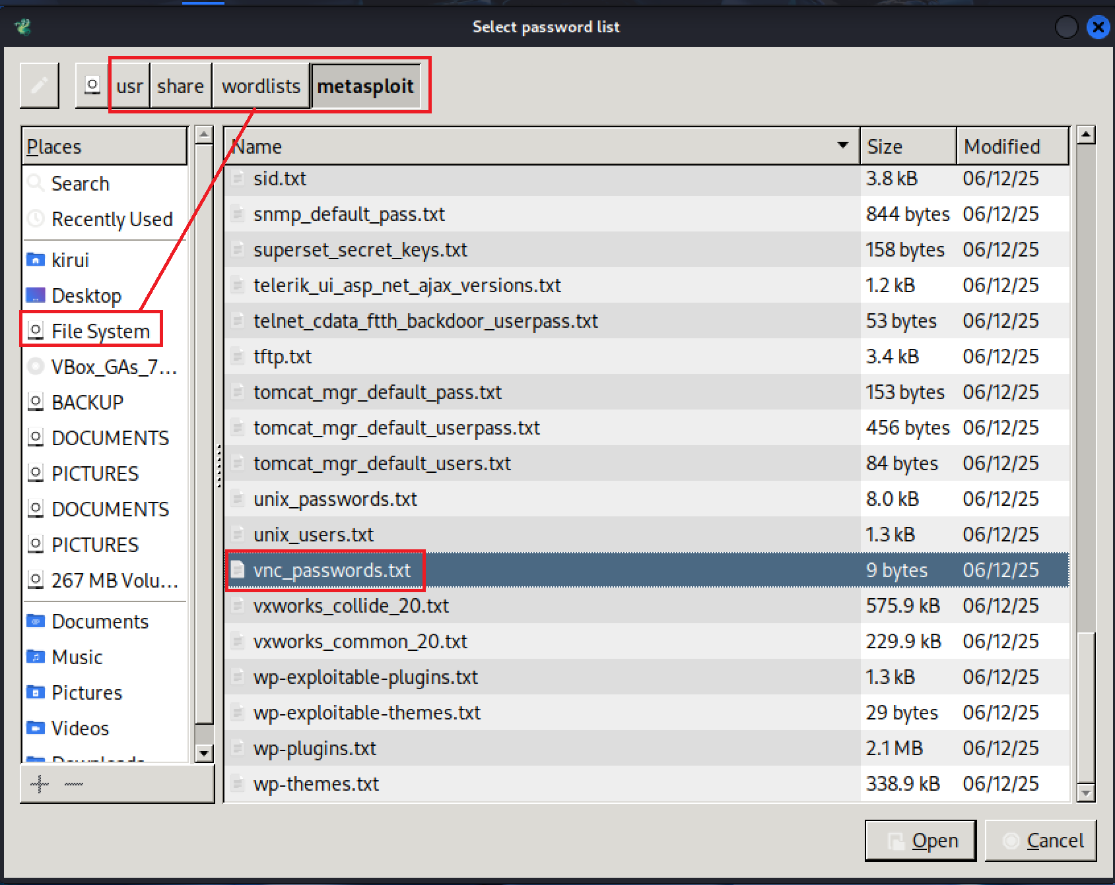

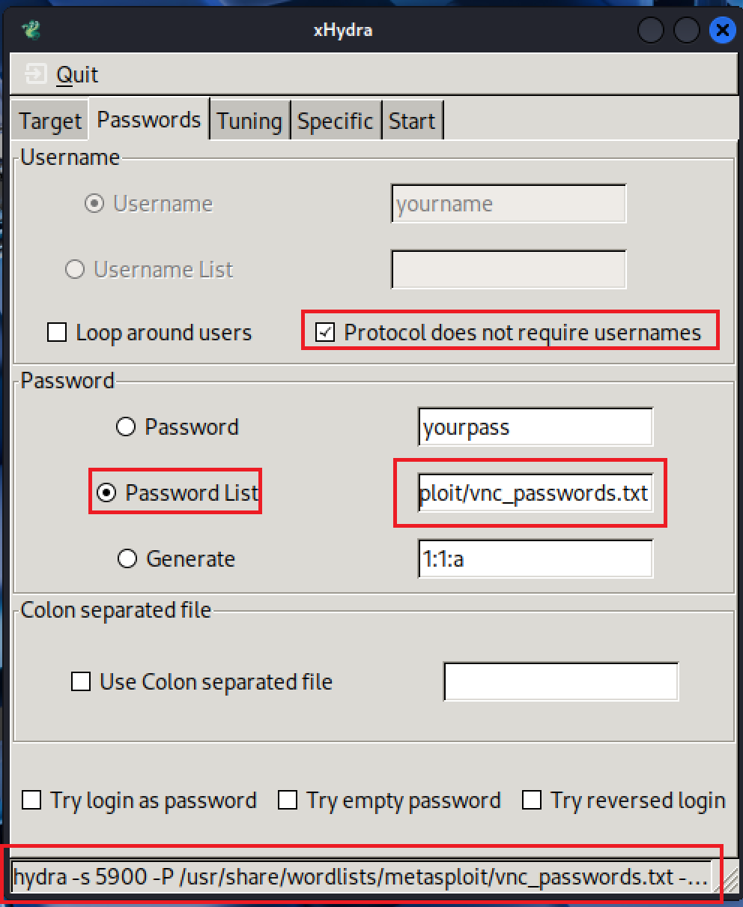

Tuning Tab
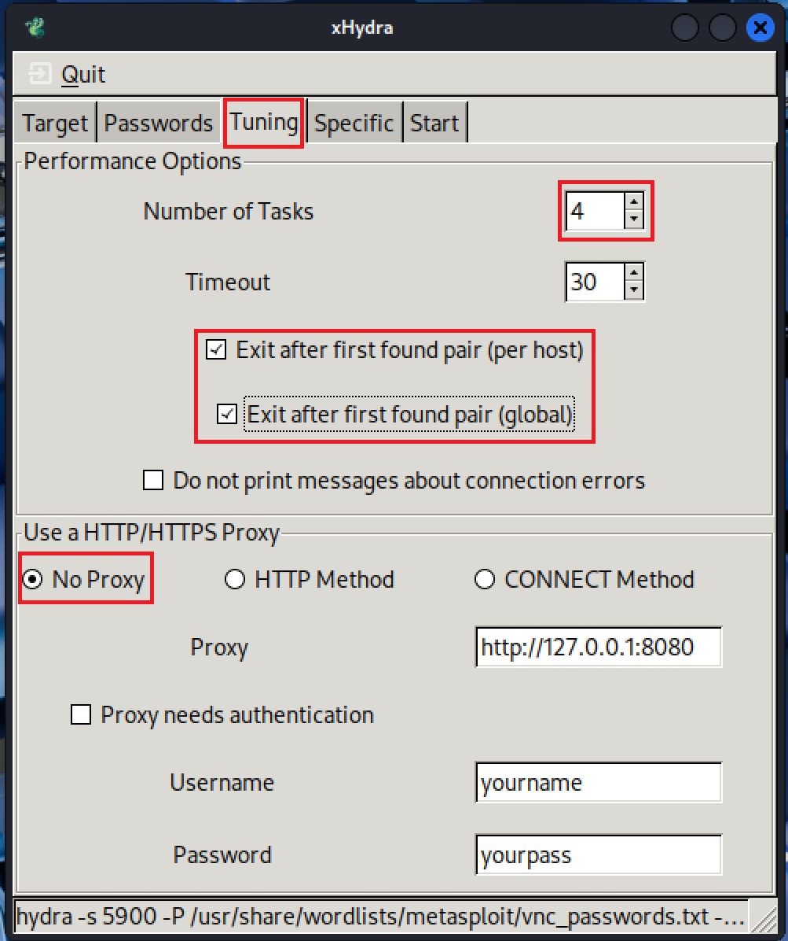

Tuning Tab


Start tab
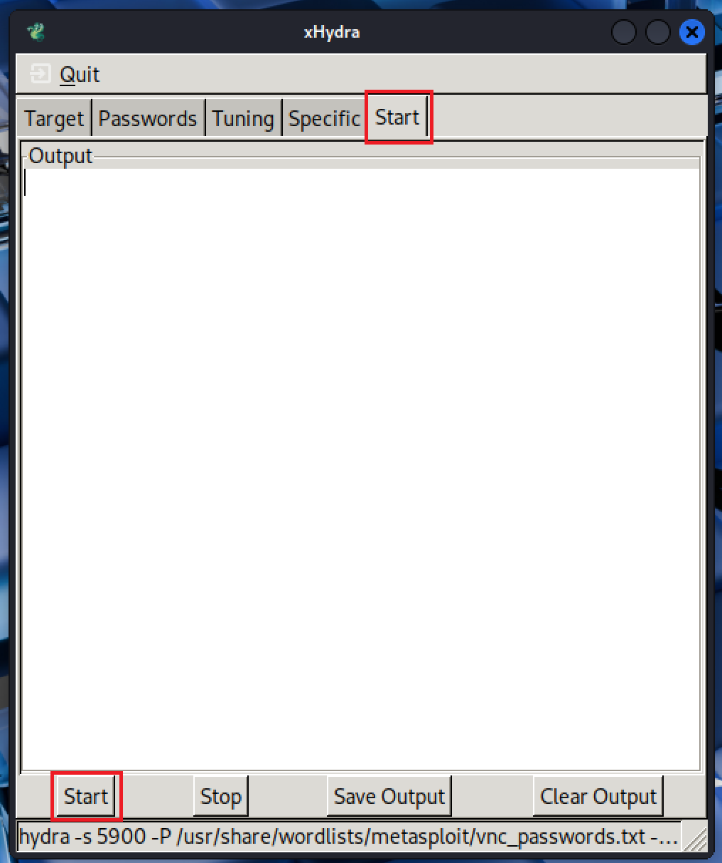

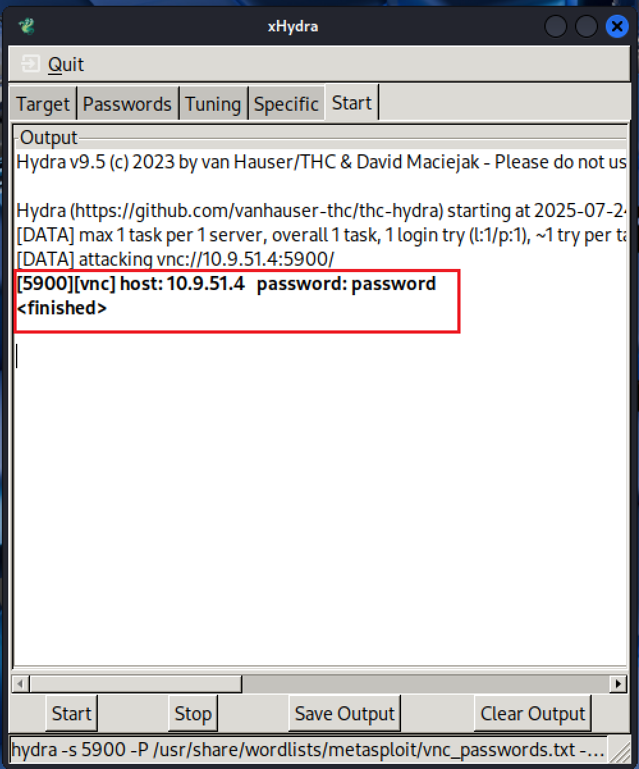

On unchecking both boxes:
